Day 42 – Model Serialization

What is Model Serialization?
Model serialization means saving a trained machine learning model to a file so that it can be used later without retraining.
When a model is trained, all the learned patterns, parameters, weights, and configurations exist only in the computer's memory (RAM). If the program stops running, this information is lost. Serialization solves this problem by saving the model permanently as a file.
Without serialization:
- Every time the application starts, We must train again.
- Wastes time and computing resources.
With serialization:
- Train once.
- Save the model.
- Load it whenever needed.
- Make predictions instantly.
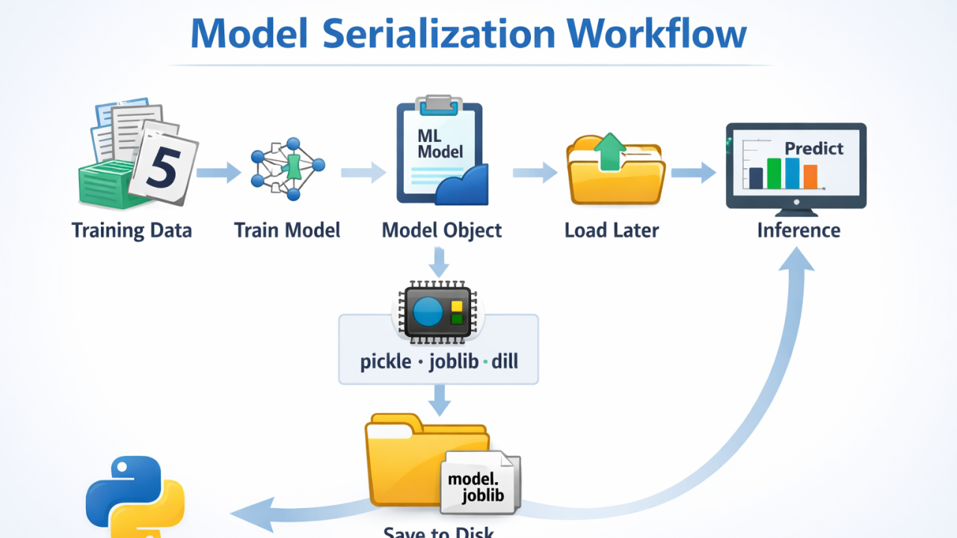

Pickle :
Pickle is Python's built-in serialization library.
It converts Python objects into a byte stream that can be stored in a file and later reconstructed.
This process is called:

Pickling :Converting object → file.

Unpickling : Converting file → object.

How Pickle Works
Suppose we have:
model = LogisticRegression()
This model exists only in memory.
Pickle converts it into a binary representation and stores it as:
model.pkl
Later, Pickle reconstructs the same model object.

Characteristics of Pickle

1. Built into Python
No installation required.
import pickle

2. Supports Many Python Objects
Can save:
- Machine learning models
- Lists
- Dictionaries
- DataFrames
- Custom objects

3. Binary Storage
Pickle stores data in binary format.
Humans cannot read it directly.
Example:
model.pkl
Opening it in Notepad shows unreadable characters.

Advantages of Pickle

Easy to Use : Very few lines of code are needed.

No Additional Libraries : Available with Python installation.

Flexible : Can serialize many object types.

Limitations of Pickle

Slower for Large Models : Large arrays take longer to save and load.

Larger File Sizes : Saved files may be larger than Joblib files.

Security Risk : Never load Pickle files from unknown sources. A malicious Pickle file can execute arbitrary code. Because of this, organizations only load Pickle files from trusted sources.

Joblib
Joblib is a Python library designed specifically for efficiently storing and loading objects that contain large numerical data.
Many machine learning models contain huge NumPy arrays.
Joblib handles these arrays more efficiently than Pickle.

Why Was Joblib Created?
Machine learning models often contain:
- Thousands of coefficients
- Large matrices
- Numerical arrays
Pickle can store them, but performance may not be optimal.
Joblib was developed to improve:
- Saving speed
- Loading speed
- Storage efficiency

Characteristics of Joblib

1. Optimized for Machine Learning
Works exceptionally well with:
- Scikit-Learn models
- NumPy arrays
- Large datasets

2. Faster Loading
Many production systems prefer Joblib because prediction services need quick startup times.

3. Better Compression
Files are often smaller than Pickle files.
Smaller files mean:
- Less storage
- Faster transfer
- Faster deployment

Advantages of Joblib

High Performance : Efficient handling of numerical data.

Faster Loading : Particularly useful in production environments.

Preferred for Scikit-Learn : Most Scikit-Learn documentation and examples use Joblib.

Limitations of Joblib

Extra Installation : pip install joblib

Mainly Designed for Numerical Objects : Although it can store many objects, its biggest advantage appears when handling large numerical data.
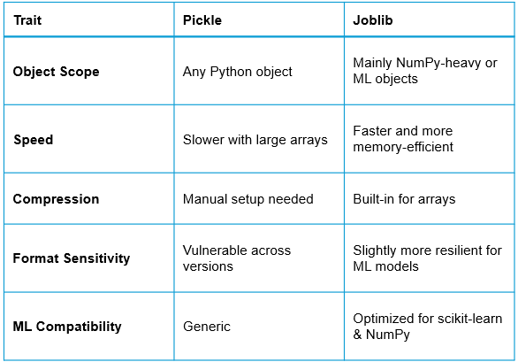

Versioning Basics

What is Model Versioning?
Model Versioning is the practice of maintaining multiple versions of machine learning models over time.
Instead of replacing old models, each new model receives a unique version number.
Example:
v1.0
v2.0
v3.0

Why Do Models Need Versioning?
Machine learning models continuously evolve.
New versions may be trained with:
- More data
- Better features
- Better algorithms
- Improved preprocessing
Each improvement creates a new version.

Real-Life Example
Suppose a bank develops a loan default model.

Version 1
- Logistic Regression
- Accuracy: 82%

Version 2
- Random Forest
- Accuracy: 88%

Version 3
- XGBoost
- Accuracy: 92%
Instead of deleting older versions:
loan_model_v1.joblib
loan_model_v2.joblib
loan_model_v3.joblib
all are preserved.

Benefits of Versioning :

1. Rollback Capability
Suppose Version 3 performs poorly after deployment.
We can immediately return to:
loan_model_v2.joblib
This process is called rollback.

2. Experiment Tracking
Versioning helps answer questions like:
- Which algorithm was used?
- What features were included?
- Which dataset was used?
- What accuracy was achieved?

3. Reproducibility
Months later, a company may need to reproduce results.
Versioning ensures the exact model can be retrieved.

4. Team Collaboration
Multiple data scientists can work on different versions without overwriting each other's work.

What Should Be Versioned?
A mature ML project versions:

Model Files
model_v1.joblib
model_v2.joblib

Dataset Versions
data_v1.csv
data_v2.csv

Training Code
train_v1.py
train_v2.py

Metadata
Information about:
- Accuracy
- Training date
- Features used
- Hyperparameters

Simple Industry Workflow
- Collect data.
- Train model.
- Evaluate model.
- Save model using Pickle or Joblib.
- Assign version number.
- Deploy model.
- Monitor performance.
- Create improved version when needed.
- Roll back if problems occur.

